Office of Regulatory Research Compliance (ORRC) HU-Biosafety Office-Quality Assurance Protocol-(QAP-EWS) Eye Wash (EW-Station): Safety Log Protocol and Record of Maintenance

“OSHA Regulation 29 CFR 1910.151(c) states – Where the eyes or body of any person may be exposed to injurious corrosive materials, suitable facilities for quick drenching or flushing of the eyes and body shall be provided within the work area for immediate emergency use”.
- Eye Wash Station SOP
The emergency eye wash station provides a means to remove chemical contamination from the eyes and/or face. Laboratory personnel should follow these guidelines when using the eye wash station:
- Eye wash stations are inspected annually to ensure they meet appropriate standards and regulations.
- Laboratory workers should flush their eye wash stations weekly to ensure clean water is available in the event of an emergency.
- Use the format given below to keep Eye Wash Station Inspection form. This will be a part of the log and record of maintenance.
- Eye wash stations should be clearly marked.
- Eye wash stations should be kept free from obstructions.
- In the event of eye contamination, the laboratory worker should hold his/her eye open and rinse for a minimum of 15 minutes.
- Then seek medical attention.

Eyewash Stations – Water Temperature
The Joint Commission Laboratory standard EC.02.04.03 addresses the inspection, testing and maintenance of laboratory equipment. This would include the temperature of the water for eyewash stations. For safety reasons there should be temperature checks to ensure the water of eyewash stations is “tepid”.
OSHA regulations (1910.1450 App A) address the requirement to have an eyewash station. American National Standards Institute (ANSI) Z358.1-2004), “Emergency Eyewash and Shower Equipment” and the 2009 Revision also address eyewash stations.

Office of Regulatory Research Compliance (ORRC) HU-Biosafety Office-Quality Assurance Protocol-(QAP-EWS) Eye Wash (EW-Station): Safety Log Protocol and Record of Maintenance

Water Temperature at Eyewash Stations (Plumbed):
ANSI standards (2004 and 2009 revision) recommend that the water temperature at eyewash stations should be “tepid”. A specific temperature is not given for “tepid” water.
Water temperature should be under 38 degrees C (100 degrees F) and above 15.5 degrees C (60 degrees F). Temperatures higher than 38 degrees C (100 degrees F) are harmful to the eyes and can increase the chemical interaction with the skin and eyes.
Long flushing times with cold water (less than 15.5 degrees C [60 degrees F]) can cause hypothermia. This may cause a staff member to not rinse or shower for the full recommended time.
- The velocity of the water should be maintained as not to injure the staff member’s eyes. Also, anti-scalding devices should be used on all eyewash stations.
- Preventive maintenance should be performed every three (3) months or as needed to check for valve leakage, clogged openings and lines and adequacy of the fluid volume.
- All testing and preventive maintenance should be documented and maintained in the Safety Office and E H & S-HU.
“If an eyewash station is in need of repair, all users should be notified and a portable eyewash station should be obtained immediately”.
References:
American National Standards Institute (ANSI) Z358.1-2004, “Emergency Eyewash and Shower Equipment”; ANSI/ISEA Z358.1-2009 Revision.
Occupational Safety and Health Administration (OSHA), Regulations (Standards – 29 CFR), National Research Council Recommendations Concerning Chemical Hygiene in Laboratories (Non-Mandatory) – 1910.1450 App A.

Eye wash Inspection Form
Office of Regulatory Research Compliance (ORRC) HU-Biosafety Office-Quality Assurance Protocol-(QAP-EWS) Eye Wash (EW-Station): Safety Log Protocol and Record of Maintenance

Col/Dept._______________________ Lab (Build/Room) _____________________ Principal Investigator_____________________ Checked by___________________________
Standard: According to the American National Standards Institute (ANSI) Emergency Eye Wash Equipment Standard Z358.1-1998, weekly flushing and testing for proper operation on the eye wash station must be performed and documented (Note: OSHA incorporated the ANSI standard with respect to eye wash station inspection.
Procedure: Weekly flush the eye wash station to ensure it is working properly and is unobstructed and accessible. Document the inspection noting any deficiencies or problem. Contact E H & S to correct any problems.
Date | 1. EW Station (Y)/(N) | 2. E.W. Station (Y )/ (N) | Initials | *Problem (Y)/(N) | Action/Comments (Need more space? Use extra space below.
1. EW Station was flushed and is in Working order. Yes (Y) or No (N)
2. EW Station is unobstructed and accessible. Yes (Y) or No (N)
Office of Regulatory Research Compliance (ORRC) HU-Biosafety Office-Quality Assurance Protocol-(QAP-EWS) Eye Wash (EW-Station): Safety Log Protocol and Record of Maintenance

Some of the Observations (Dont’s) of the EWS-Inspection on 04/08/14
  - (2)
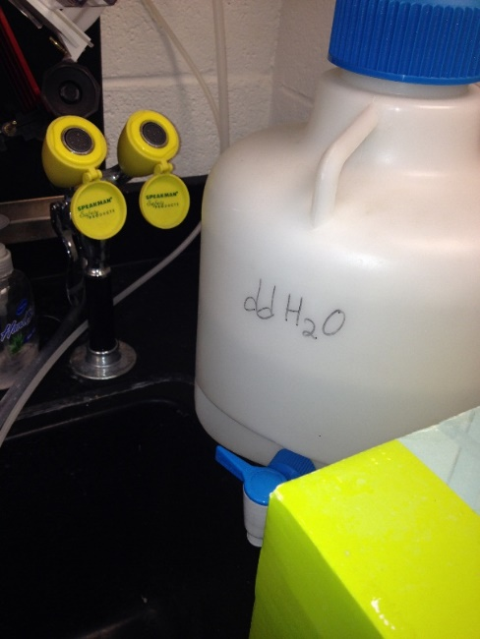 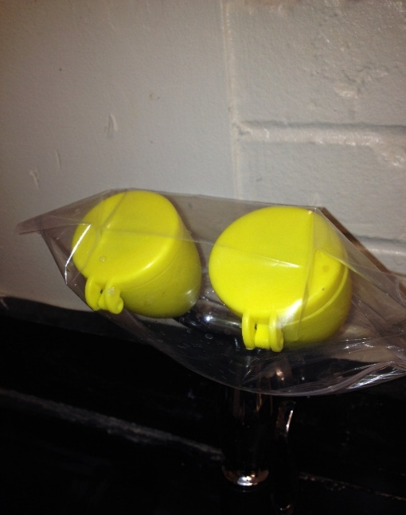 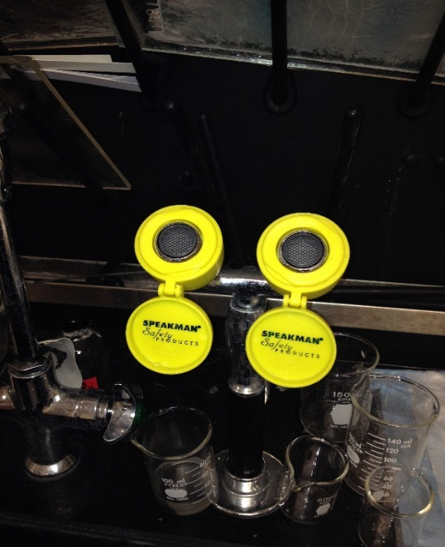 (3) (4) 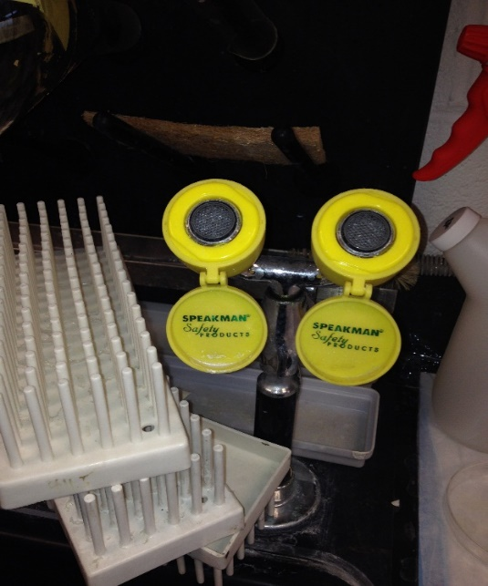

Office of Regulatory Research Compliance (ORRC) HU-Biosafety Office-Quality Assurance Protocol-(QAP-EWS) Eye Wash (EW-Station): Safety Log Protocol and Record of Maintenance

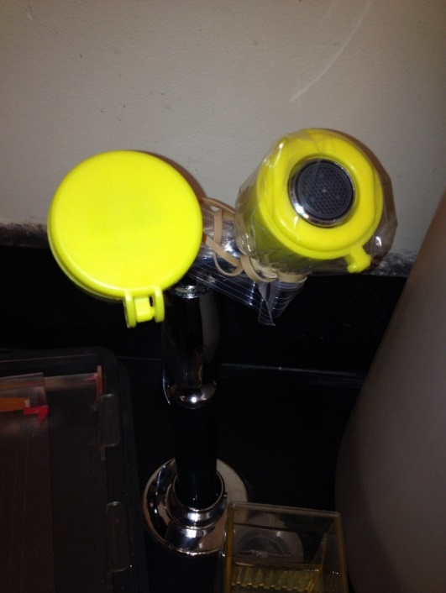 (5)
Sometimes when labs are inspected, these are some of the photographs that depict certain Don’ts practices. However, as the initial inspection was educational, all these and more are instructed regarding the proper use and maintenance of the EWS.
We need all the labs equipped with and inspected on a routine and a scheduled basis.

